**Infant Room**

**Parent Handbook**

**The Basics**

• Your baby must be at least 6 weeks old to be enrolled in our infant program

• The program is offered:

M -Th 7:30-5:30 pm and Fridays 7:30 am -4:00 pm

• The teacher:child ratio is 1:4, 2:9 and 3:11

**Our Philosophy**

Our program is geared towards enriching the whole child, focusing on the physical, emotional, social, and cognitive areas of development. We facilitate positive self-image and emerging language skills by providing a warm and loving atmosphere in which the uniqueness of each child is celebrated. The Solel Preschool is the ideal setting for children to form their first friendships. We provide a stimulating environment that cultivates the child’s natural curiosity to discover their world in a richly Jewish setting.

We believe it is never too early to work in partnership with each family to help each child develop a bank of warm Jewish experiences.

**Daily Communication:**

Communication sheets will be available about your baby’s eating, napping, diapering and activities daily. The bottom of the report will tell you when we need more food, diapers, wipes, etc.

**Phone Calls**

**The Preschool’s phone number is 480. 991.4545**

You are welcomed to call the preschool if you need to communicate with the teachers during the day. The School Office will answer the calls and check with the teachers to ask if they are available to answer the phone. If they are busy, they will call you back at their earliest convenience, or if you have a specific question please let the office know and they will try to find out the answer.

Your baby and his or her needs are the teacher’s first priority. Please understand that they are caring for your baby and may not be able to answer the phone immediately.

**Supplies:** \***Please label all supplies with the baby’s first and last name\***

We ask that you bring the following:

* Diapers
* Wipes
* Diaper ointment
* Extra formula Plus 1 bottle empty
* Food (we serve age appropriate snacks; grahams, Ritz crackers, goldfish, etc. when baby is ready for them)
* Bottles pre-made ready to be warmed
* Burp Cloths
* Bibs
* Sippy cups
* Baby food containers
* Crib Blankets
* At least 2 Change of clothes (size appropriate and seasonal)
* Hat

**What Happens in the Infant Room Each Day?**

**Play Time**

Our infant room is arranged to enable learning and exploration with safety first. We provide age appropriate toys that enhance cognitive development together with large muscle development and fine motor skills.

Through play, babies begin to understand themselves, others and the outside word. They also develop their ability to communicate with others.

We provide a fun and loving environment that will nurture your baby’s development and needs. Here is a sample of some of the fun activities we do each day:

• We sing and play age appropriate games

• We read books to the babies.

• We have tummy-time for the younger babies.

• We play happy music all the time (nursery rhymes, classical, Jewish music, etc.).

• We play with blocks, pop-up toys, etc.

**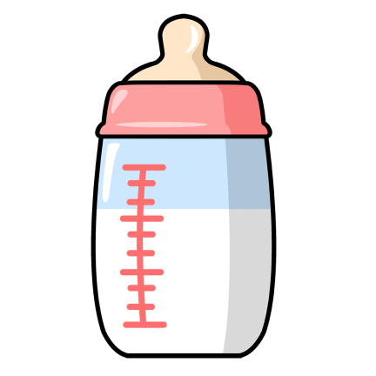Feeding Time**

We will ask you to fill out a feeding schedule telling us what your baby eats and drinks, how much, and when you last fed him or her. Please feed your baby at least one bottle before school. We want to follow a schedule that meets your wishes, but most importantly, meet the demands of your baby. Your baby will be held during each bottled feeding unless you instruct us otherwise.

**Diaper Changing**

You supply diapers, wipes, diaper ointment, powder, or anything else you would like us to use when diapering your baby. We ask that you supply enough diapers and wipes for the month. We will let you know when the supply is running low.



The diaper changing area is separated from other areas. Diaper changing can be a treat when it comes with that special song or rhyme.

During each diaper change disposable gloves are worn. Once baby is changed, the diaper area is sprayed with bleach water followed by a soap solution to clean and sanitize the area.

**Nap Time**

We will provide your baby with their own individual crib that only they will use on their scheduled day. We will supply the sheets, but ask that you bring in baby’s favorite blanket, stuffed animal or any other item that will give the crib that “homey feeling”! We will allow your baby to nap on his or her schedule and play soothing lullabies during naptime.

**Snuggle Time**

There are lots of times throughout the day for your baby to experience “snuggle” moments with their teacher. Our teachers love the babies and find those special one on one moments with each child priceless.

**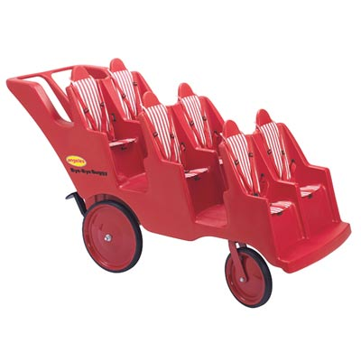Outside Fun**

Weather permitting, we will take your baby outside each day. We have a six-seat canopied buggy as well as a double stroller. We may take a walk to the playground to watch the older children play or just wheel them around the schoolyard or even stop in to say hello to the Rabbi. The babies love to go outside and sit in the exersaucers, bouncy seats or swings to feel the warm sunshine and get some fresh air!

**Health**

Your baby’s health is of major importance to all of us. You will be asked to fill out a “blue” immunization card as well as emergency information. These items must be completed before admission to our program, in accordance with State law

**Illness**

\*\*\*Please refer to parent handbook\*\*\*

Contagious Illnesses that Must Be Reported to the School Immediately:

o Fifths Disease

o Camplylobacter

o Chicken Pox

o Coxsakie (Hand, Foot & Mouth)

o Giardia

o Hepatitis

o Impetigo

o Lice

o Measles

o Meningitis

o Mumps

o Pinworms

o Ringworm

o Roseola

o Rubella (3 Day or German Measles)

o Salmonella

o Scabies

o Scarlet Fever

o Shigela

o Strep Throat

\*We do not give Pedialyte at Solel. If your baby was sick and still needs Pedialyte, they are not yet well enough to return to school. Please keep them home until they are symptom free for 24hrs.

**Your baby must meet the following conditions to return to school:**

• Free of fever for 24 hours (without medication/Pedialyte)

• Free of vomiting for 24 hours without the help of medication/Prdialyte.

• Free of diarrhea (frequent greenish or watery bowel movements) for 24 hours without the help of medication/Pedialyte.

• A child may not return to school after bouts of vomiting and/or diarrhea until they have kept down two full meals without the help of medication/Pedialyte.

• 24 hours following conjunctivitis (redness, puffiness or green-yellow discharge, and given drops.)

• Any illness requiring antibiotic treatment, after 24 hours of treatment.

• Chicken pox may return after all lesions have scabbed over and are dry (usually 6-7 days after initial outbreak).

* We may ask for a doctor’s note clearing your child for school at the office staff’s discretion.

**Medication at Home and School**

**If your baby is receiving any medication at home**, **please notify**

**the staff when you bring your baby to school**. It is imperative

that we have this information should there be any type of side

effects or your baby just isn’t acting like him or herself.

If your baby requires medication at school, you must fill out a Request to Give Medication form and have a note from your baby’s doctor stating the reason, dosage and times to be given. You must give the form, along with the medicine to the front office.

**DO NOT LEAVE ANY MEDICATION IN YOUR CHILD’S BAG.**

 *All medicine must:*

* Be in the original bottle.
* Labeled by the pharmacy with:
  + Baby’s name
  + Dosage (how much and how often)
  + Doctor’s name and telephone number

**Teething**

When babies start teething it hurts. If you want us to give Infant Tylenol or Motrin to ease the pain, we need a “**Request to Give Medication” form to be able to administer this medicine.**

\*Do not give Motrin to babies younger than 6 months old\*

Teething **does not** cause **high fevers** or **colds**. Your baby’s resistance may be lowered during teething, but it does not cause infections.

*They may show the following symptoms*

* BD09470_Irritability and crankiness
* Refuse the bottle (sucking hurts)
* Drooling
* Rashes around the mouth
* Loose stools
* Swollen, red gums
* Diaper rash
* Clear, runny nose
* Loss of appetite
* Biting fingers, toys, etc.

**Birthdays**

We know how special that “first” Birthday can be and welcome a small celebration in the classroom. Please discuss with the teachers a week before if you would like to come in for a special activity.

We ask that you plan the celebration time with the teacher as not to disrupt naptime. **Also we ask that you be there to help with the celebration and allow time for you to set up and clean up.**

If you are planning a party at home, we ask that you not pass out invitations at school if you are not including all the babies. Extend your invitations by mail or phone.

**Jewish Curriculum**

Friday is our favorite day, when we prepare for Shabbat. The Temple Solel clergy conducts a special Kabbalat Shabbat (welcoming Shabbat) for the preschool. Just sitting in the buggy and hearing the prayers and songs, is an enriching activity. It is never too early to begin develop a positive Jewish identity. Often enriching sensory-based activities are planned f or Jewish holidays and celebrations. Parents are always welcome to join their babies in sharing these special times.

**Final Thoughts**

Each baby is a unique individual. To watch a child grow and develop is truly amazing.

Working together with parents and teachers, forming warm and loving bonds and providing positive stimulation can make a difference in a child’s development for a lifetime.

**Thank you** for the opportunity to care for your most precious baby. We work hard to earn your respect and take our responsibility most seriously.